When Robot Bleed GDD v.2

Version1.1

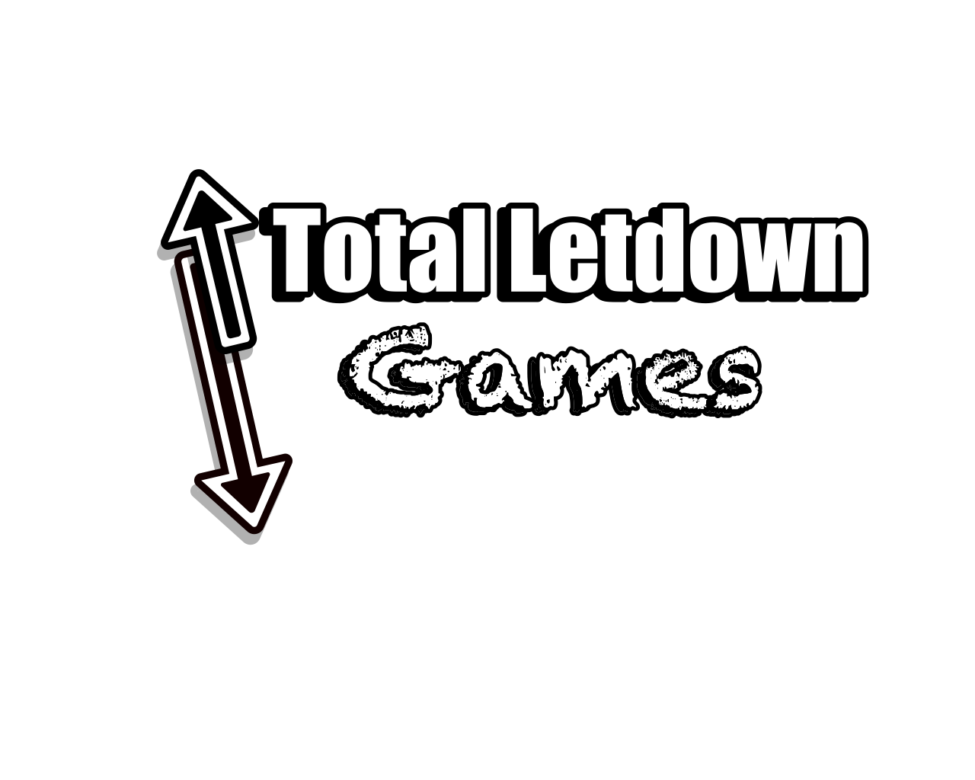

By

Team Members: Joseph Pak, Emanuel Dorsey, Marcus Queiro, Wyatt Walker, Raphael Brown, Robert Newman, Laila Abuelhawa, Jason Leung, Simi Virdi

11/15/2023

**Game Overview 3**

**Gameplay and Mechanics 4**

Main Objective of the game 4

Game Progressions 4

Player Mechanics 4

Unlockable ability and upgrade 4

**Controls 6**

**Story, Setting, and Character 7**

**Levels 8**

Area 1: Factory Junkyard 9

Area 2: Magma Metal Factory 10

Area 3: Storage Room 11

Area 4: Old Garden 12

Area 5: The Lab 13

**Interface 14**

**Audio 15**

Music 15

Sound Effects 15

**Enemies 17**

**Technical 19**

**Concept Art 21**

**Live Service Plan 25**

# 

# Game Overview

**The main concept of the game**:You play as Beta-14 that has to awoken in a broken-down factory.

**Unique Features**:

* Deal with challenging enemies that will constantly try to kill you in every corner
* Special Bots that will chase you relentlessly making you run to hide to escape from them.
* Emercel Experience this world that has been lost to humanity and all that remains in this desolate world are the few remaining robots that humanity created.
* Enjoy exploring and being lost in a giddy and lost factory that will make you feel alone.

**Genre**: 2D Metroidvania platformer with an element of survival horror.

**Target Audience**

The target audience for the game is PC gamers, particularly Steam users, who enjoy 2D platformers and Metroidvania-style games.

Age:13 and up

**Game Flow Summary**

To destroy the threat causing robots to destroy each other and escape the factory. Explore the factory and make your way to the final area where the main threat is hidden. Each area holds a special keycard that progresses the game. After collecting 4 key cards, use them in the final area to escape the factory.

# Gameplay and Mechanics

## Main Objective of the game

Destroy the AI that is causing most other robots to become hostile and escape the abandoned factory. Explore the factory to locate the AI while evading the hostile robots. Each area, four areas in total, holds a special key card that allows for progression into the next area. Once all 4 key cards are obtained, you will be able to escape the factory which ends the game.

## Game Progressions

The player will progress through the game by opening the facility and trying to get to the AI. In order to progress in the game, the player will need to gain a critical ability that will help in opening new areas. This enemy is unkillable and can only be stopped after the sequence is over. After the sequence is over the player can then backtrack and unlock the next new area to explore. Some areas will have this hunter enemy that will relatively hunt the player. Defeating them will give the player these key cards as well as an upgrade to one of the player's abilities.

## Player Mechanics

The Player will have a hp meter starting with 100 hp. The player will take damage from the environment and from enemies.

## Unlockable ability and upgrade

* In the game, the player will be able to find new abilities to use in the game that will help with both progressing through the levels and combat.
* Abilities include double jump, energy sword, energy blast, and sprint.
* Early on in the game, the player will gain access to the energy sword and blast that will allow them to complete the puzzles to progress further into the game.

**Player arsenal:**

* **Unlockable ability:**
* Dash: allows the player to dash in the air or ground for a set distance (like the one in Hollow Knight) – located in the junkyard Area 1
* Grapple Hook: Grab onto magnetic points within the areas and swing onto platforms to advance towards more difficult-to-reach areas.
* **Weapons:**
* Energy Sword: The player's first weapon is the energy Sword which the player can swing to damage enemies in front of them as well as destroy wooden boxes.
* Gun: The second weapon used by the player and the first to use energy. Shoot out energy bullets to damage enemies at a far distance. Only goes in front of the player but can be shot when jumping. (like in Mega Man) The gun can also be used for activating switches by shooting at them.

# Controls

* A & D: Move left and right
* Spacebar: Jump
* Hold Shift: Run
* J: Blade
* K: Blaster
* L: Dash
* H: Grapple Hook
* M: for the map
* ESC: Pause menu

# Story, Setting, and Character

When Robots Bleed

The year is 30xx Humanity is gone and in its place is the society of robots. However, robots from a factory are broken down and scraped. A virus has spread down in the factory and now all robots have turned hostile and destructive. Your Beta-14 has awakened deep down in the junkyard of an old abandoned factory. The only objective is to try and find the exit to the factory. Journey down into the factory and survive deep within this factory full of broken and dangerous infected robots out to destroy you.

The broken factory - this facility was known as the Largest factory that produced robots in the world it was also known to have many technological advancements

Beta-14 is one of the broken robots that was reactivated in the old junkyard. Trying to look for a way to escape the factory. Although there may be more to this robot than meets the eye (note: this was one of the first beta robots designed with the capacity to learn and adapt).

# Levels

**The world:**

The overall level layout is heavily based on games like Metroid and Hollow Knight where the player will find themselves at dead ends but then will gain a new ability to open up new paths and doors. The game will encourage backtracking and finding secrets but will make sure that things that will need to go back to will not take too much of the player's time.

**World Map**

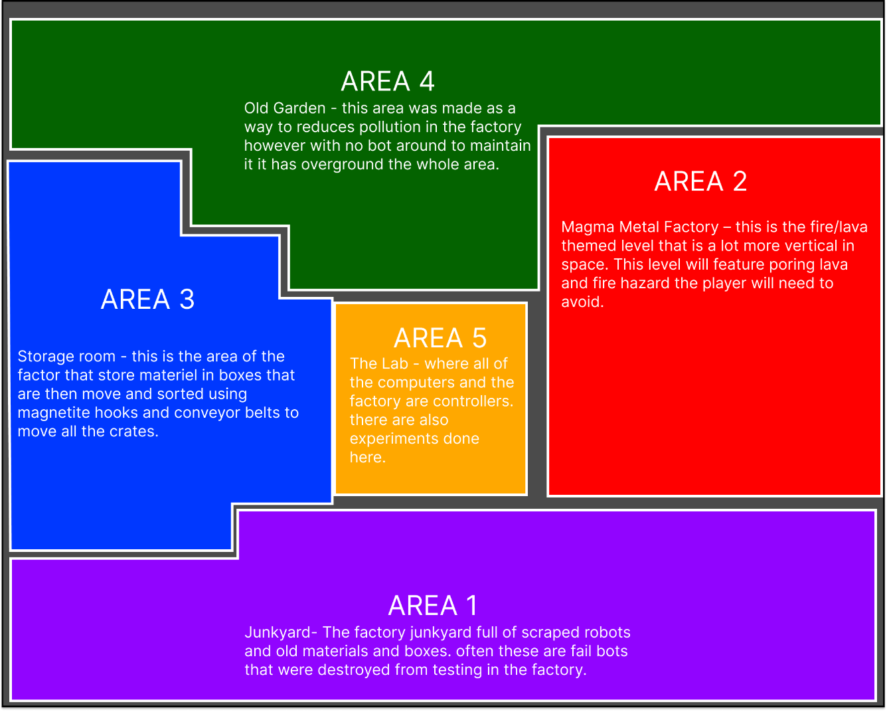

4 Distance area located inside the abandoned faction with only the remains of the robots left in its place.

Each of the areas has to save zones that the player can use to save the game progress as well as heal the player to full health.

## Area 1: Factory Junkyard

* scrap metal graveyard -This is where all leftover junk and scrap goes until it’s processed through the factory for dismantlement or just recycled into new parts. Many of the robots here have already been deactivated before being scraped into the grave although some are still just barely functioning.

**Enemies:**

* Walker - Once a worker robot, but now it roams the area looking out for anything that is detected as “dangerous”. It shoots its rifle in three short bursts from afar and does a melee attack when the player is too close.
* Hunter - Agile, and precise, the Hunter is eager to hunt and is able to pounce at anyone in one and bleed its foe.

**Items and Level gimmick:**

* Lock doors and keys
  + 2 lock doors (one opens with a key) (other opens by a switch)
* Switches - that can be shot with the gun.
  + Switch that will open one lock door.
  + Switch that will make platforms appear or move.
* boxes - block the pathway and can be destroyed with the blade.
  + Boxes will reappear after leaving the room.
* Crushers – blocks that will fall from above that can do damage to the players.
* Power-ups / Abilities will be located around this area.

**Power Ups & Weapons/ Abilities:**

* Energy Blade

**Area 1 timeline**

* The Player starts in the open in area 1.
* The player will platform up a wall (2 rooms)
* The Player will get the energy blade.
* The player will find a locked door.
* The player will find the key to lock the door.
* The player will be blocked out of going down. They will need to activate a switch.
* Players will get the first key card.
* Play needs to escape from the hunter.
* Play will reach the room with an elevator (using the key card to activate it).

## 

## Area 2: Magma Metal Factory

* Magma Metal Factory – this is the fire/lava-themed level that is a lot more vertical in space. This level will feature pouring lava and fire hazards the player will need to avoid.

**Enemies:**

* Same as area 1
* Super hunter 2

**Items and Level gimmick:**

* Lock doors and keys: a total of 3 lock doors and 3 keys
* Switches – switches that will activate Platforms and Walls.
* Lava – the floor is lava if the player touches the lava will be damaged if they are in the lava. Lava is also pouring out on a few walls.

**Power Ups & Weapons/ Abilities:**

* Plasma Gun

**Area 2 timeline**

* Player arrives from the elevator.
* Players must then navigate down for a key and unlock the above area.
* Players will need to avoid lava and find the next key to open the area down further to the right.
* The player will then gain access to the Plasma Gun ability (they will use this to turn on or off switches
* The player will then climb back up to get the last key and unlock the last door to get the next keycard.
* After getting the key card the new hunter of said area will start chasing the player.
* The player will escape the hunter and get to the elevator to move to area 3.

## 

## Area 3: Storage Room

* Storage room - this is the area of the factory that stores material in boxes that are then moved and sorted using magnetite hooks and conveyor belts to move all the crates.

**Enemies:**

* Same as area 1
* Super hunter 3

**Items and Level gimmick:**

* Lock doors and keys: a total of 2 lock doors and 2 keys
* Magnetic hooks – using the magnetic grab to move to those points
* Lava
* Sawblades

**Power Ups & Weapons/ Abilities:**

* Magnetic Grab: allows the player to magnetically grab hooks (like a grapple beam) allowing for them to move to those hooks.

**Area 3 timeline**

* Player arrives from the elevator.
* Player will the roam around until seeing a long hallway with spikes all the way.
* The player will go to another room until finding a locked door.
* The player will then find a key and go back to open door (short distant)
* Player will then find the magnetic grab ability.
* Player will go back long hallway and use the grab to travel the long spike hallway via magnetic hooks.
* Player will then find the next key that will unlock the last door.
* The player will use magnetic grab to each lock door and then get keycard 3
* The hunter will then start chasing the player with the key card.
* Player will need to navigate back to the elevator.

## Area 4: Old Garden

* Old Garden - this area was made as a way to reduce pollution in the factory however with no bot around to maintain it has overground the whole area.

**Enemies:**

* Same as area 1
* Super hunter 4

**Items and Level gimmick:**

* Lock doors and keys: a total of 4 lock doors and 4 keys
* Switches – will activate platforms and water pumps.
* There are obstacles - that will fall from above that can do damage to the players.
* Magnetic hooks – using the magnetic grab to move to those points

**Power Ups & Weapons/ Abilities:**

* Air Dash (dash on the ground or in the air)

**Area 4 timeline**

* Player will navigate around tall vertical walls.
* The player will need to find two keys to open the gate to move forward.
* The player will find the dashing ability
* The player will use the dash ability to get the third key to open the last area from above them.
* The player continues to the right and gets the final key card. The navigate back and finally get to the final area.

## Area 5: The Lab

(Current scrap- will be used instead as the end-game goal)

* The Lab - where all the computers and the factory are controllers. There are also experiments done here.
* This last Area will contain the Place where the player will use all 4 keycards.

**Enemies:**

* No Enemies

**Items and Level gimmick:**

**Power Ups & Weapons/ Abilities:**

* N/a

**Area 5 timeline**

# **Interface**

**UI**

**Title Screen**:

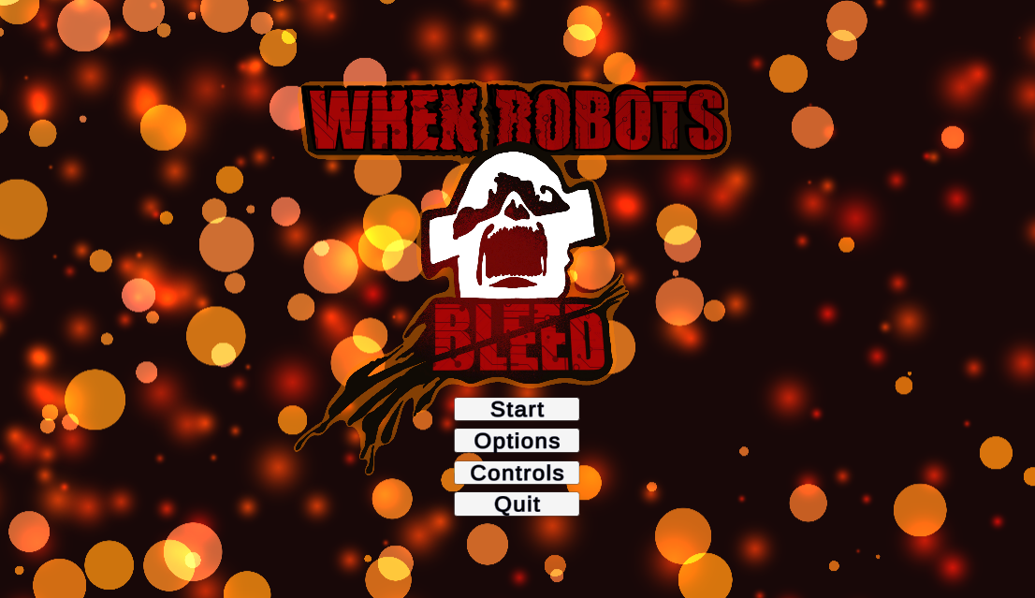

* The title Screen will have the name of the game, when robots bleed, in bold font maybe in an artistic font. Maybe With art related to the game and genre(s) of the game.

**Main menu**:

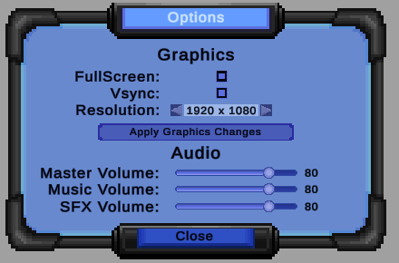

The main menu will include:

* Start: Begins story mode
* Options: Includes video and audio settings
* Controls: Provides a visual aid for the controls of the game
* Exit Game: Closes the game

**Pause menu**:

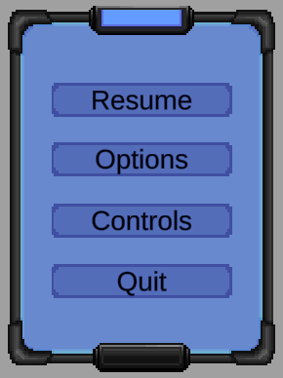

* Continue/ Resume
* Options: Includes video and audio
* Controls: Provides a visual aid for the controls of the game
* Quit: Returns player to Main Menu

# **Audio**

## **Music**

**Title screen:**

* A Cyberpunk/Trance theme plays, invoking a sense of seriousness and danger—a theme constant throughout the game.

**Levels:**

* Each level will have synth-wave elements but will focus on dark and gloominess to fit the environment

## **Sound Effects**

**Title, Main menu, & Pause screens:**

* UI button noises for interacting with different features for the title, main menu, and pause screens all having a synthesized sci-fi tune to them:
  + Button noise for hovering over an option
  + Button noise for confirming a selection
  + Button noise for clicking back
  + Button noise for a slider option

**Player:**

* Player-specific sounds for weapons, status, and movement:
  + Footsteps that match the environment the player is in
  + Dash: A gust of air to indicate the dash
  + Jump/double jump: A mechanical hinge sound
  + Blaster: A shot with an explosion on impact
  + Blade slash: A synthesized laser sound with a clash to indicate a strike
  + Death: A malfunctioning robotic sound that decrescendos down
  + Hurt: Robotic grunt that is getting close to shutting down

**Enemies:**

* Different types of enemies will vary in sound based on their appearance and attacks. All enemies will have a robotic alert sound to indicate that they have noticed the player.
  + **Walker:** Gun blaster sounds and heavy footsteps to show its slow pace and reliance on its ranged attacks.
  + **The Hunter:** Slashing sounds for its attacks, a windy sound for its dodge, an air release for its leap attack, and light footsteps to indicate its high agility.

# Enemies

Enemies, in general, will most likely have an indicator on when it's going to attack, like a glowing red marker on top of their head showing that they are ready to attack

**Walker**

* **Movement and attacks**
  + Left and right movement
  + Shoots three pellets when the player is in sight on the same level
* **How to beat (depending on the level of player or weapon could be lower)**
  + 3 hits with the melee weapon
  + 4 hits with ranged

**Crawlers**

* **Movement and attacks**
  + Moves one direction but will follow the wall.
* **How to beat (depending on the level of the player or weapon could be lower)**
  + 1 hit with the melee weapon.
  + 2 hits with ranged.

**Shooters**

* **Movement and attacks**
  + Stand still in one place and shoot a projectile left or right if it see the player.
* **How to beat (depending on the level of player or weapon could be lower)**
  + 2 hits with the melee weapon
  + 4 hits with ranged

**Hunter**

* **Movement and attacks**
  + Left and right movement
  + Can jump/teleport up to or down to platforms to where player is currently located
  + When the Hunter is attacking, It will jump forward to attack
* **How to beat (depending on the level of player or weapon could be lower)**
  + Melee is the only option to deal damage to it
    - 2 hits with the melee weapon
  + Ranged is ineffective and will be dodged by the Hunter
    - N/A hits for ranged

**Type of Hunter**

* + Each hunter is unique to each zone.
  + The Hunter will have one unique way of getting the player.
* Hunter in area 1
  + Has Average speed. (Little slower speed than the player.)
  + Follow the player when in range.
  + Chase the player linearly and only will stop when the player is out of sight.
  + Roam around at the bottom floor of area 1.
* Hunter in area 2
  + Is much faster in speed.
  + When in range of the player’s sight will fully dash to the player in one direction until it crashes into a wall.
  + Is immune to lava and fire and will ignore them.
* Hunter in area 3
  + Instead of chasing the player, this hunter will try to use a grab-like attack to grab the player and pull them.
  + The hunter if seen the player will take aim and then shoot out their magnetic hook to the player (the player can doge the attack with good movement)
  + The player will need to wiggle out of the grab before the hunter is in range to attack. (Or the player must attach a magnet hook to avoid being grabbed)
* Hunter in area 4
  + Unlike all the other hunters this one can fly and will always chase the player through walls.
  + However, this hunter is much slower than the other 3 hunters before them.
  + This hunter will also shoot the player with sticky webs that the player will need to use claws to remove.

# Technical

**Game Engine:**

* We will be using the game engine Unity, developed by Unity Technologies, to create the game. Specifically, we are using the [LTS 2021.3.18f1 build](https://unity.com/releases/editor/qa/lts-releases). The game will be developed using C#.

**Target System:**

* The game will be developed for PC (Microsoft Windows), with the intention of launching on Steam.

**Version Control:**

* A private repository of all code will be maintained using [Github](https://github.com/).

**Plug-ins and Add-Ons:**

None used yet!

**Code Objects:**

* Player object: This is the character the player controls.
* Enemy objects
  + Basic enemies:
    - Walker
    - Hunter
* Camera object: Orthographic camera that follows the player object.
* Item objects: Usable, consumables, and collectible items. Some items may be placed into inventory upon picking up
  + Key: For locked doors. Placed into inventory and used when interacting with the corresponding door.
  + Consumables: used automatically upon pick-up. Includes health and bullets for ranged weapons with limited ammunition.
* Interactable environment objects
  + Switches: can be activated by attacking (ranged or melee)
  + Cardboard boxes: destructible objects that block paths and may hold consumables.

**Basic Enemy AI and Mechanics:**

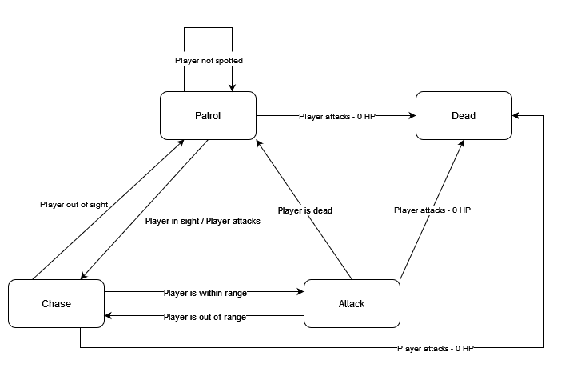

Basic enemies include the Walker and the Hunter.

**Behavior** *(see FSM above)*:

* Basic enemies have a patrol range. The enemies will continue to patrol until 1) the Player attacks or 2) the Player is spotted within sight range. If the player attacks an enemy and the enemy's HP is calculated <=0, the enemy dies.
* When the player is spotted, or after the player attacks the enemy unspotted (ambush from behind) and doesn’t deal mortal damage, the enemy goes into a chase state.
* If the player is within the enemy’s attack range, the enemy will attack.
* If the player leaves the enemy’s sight or patrol range for an amount of time, the enemy will disengage and transition back to the patrol state.
* The range in which an enemy can chase the player may be different from its patrol area.

**Specific Monster Behavior Notes:**

* **Walker:**
  + This is a very basic enemy that follows the behavior discussed above.
* **Hunter:**
  + The Hunter has a very large patrol/chase range and should be able to pursue the player over longer distances.
  + The hunter’s sight range when patrolling should be moderate to allow players to try and evade them.
  + It should be harder for the player to cause Hunter enemies to disengage or lose interest, however. The time it takes to lose interest in the player when the player is “out of sight” should be longer.

# Concept Art

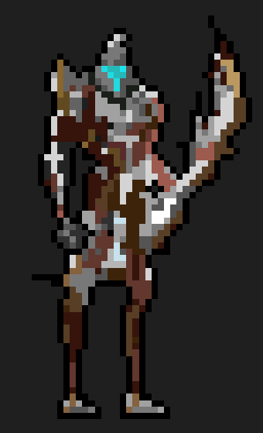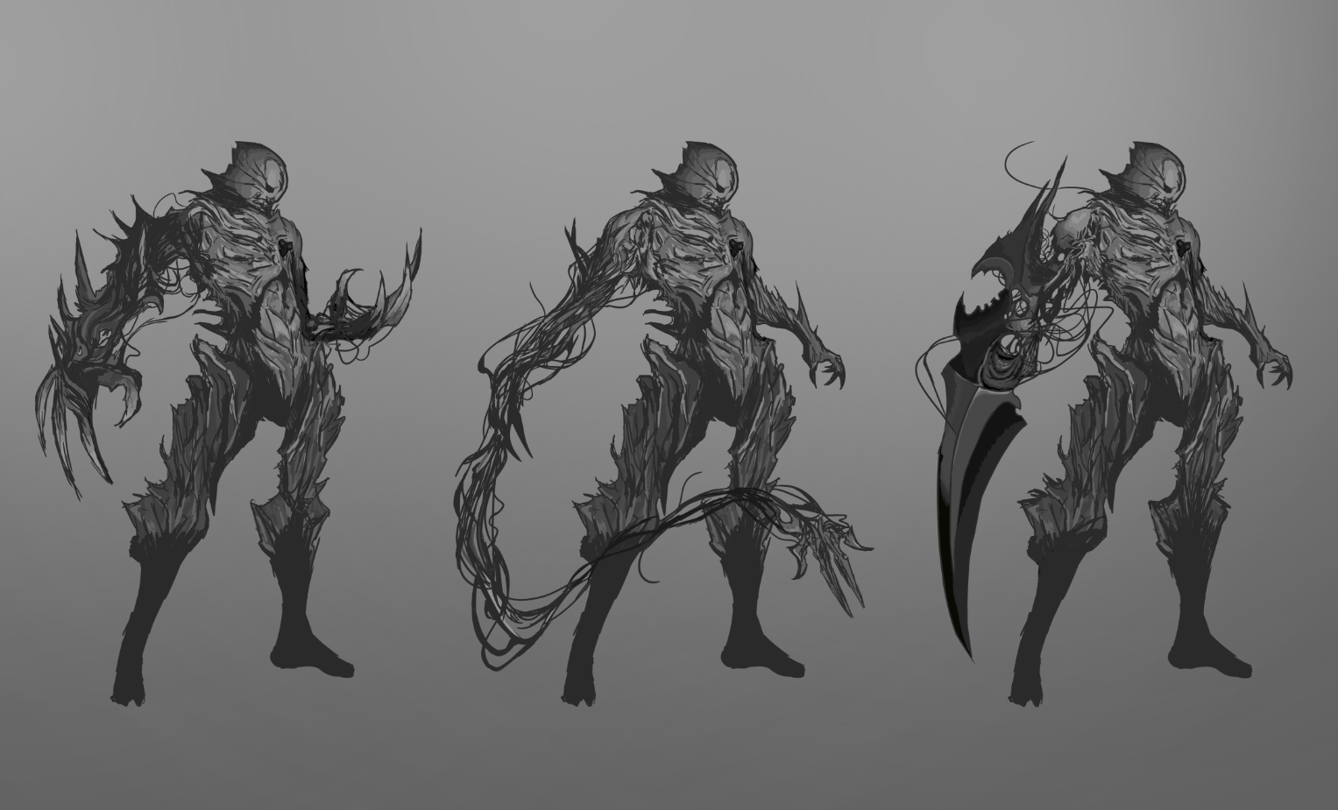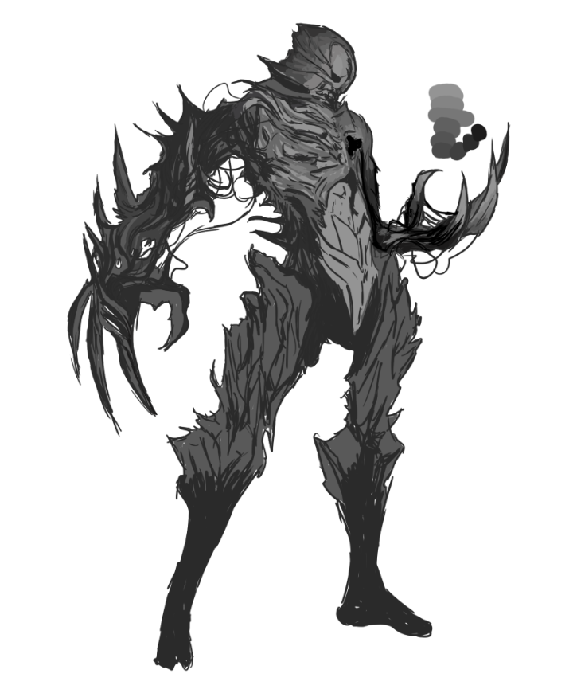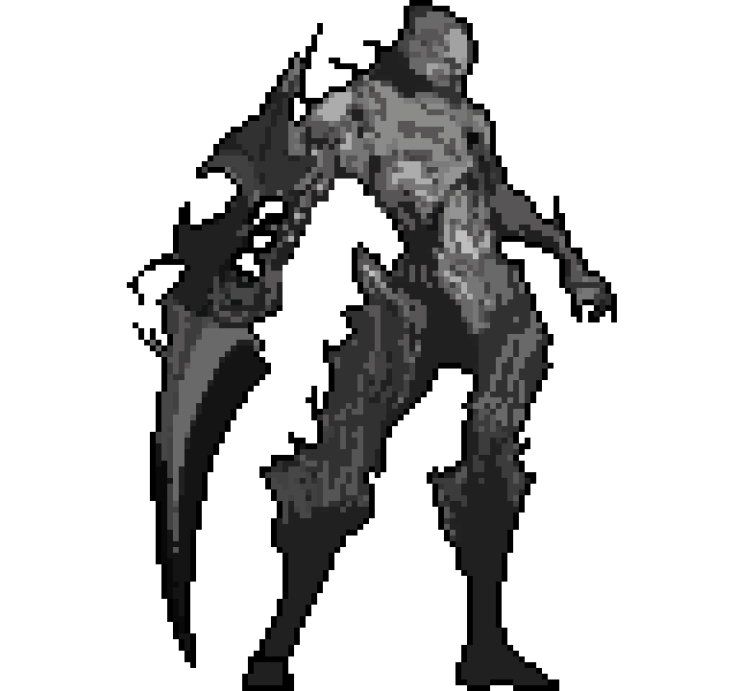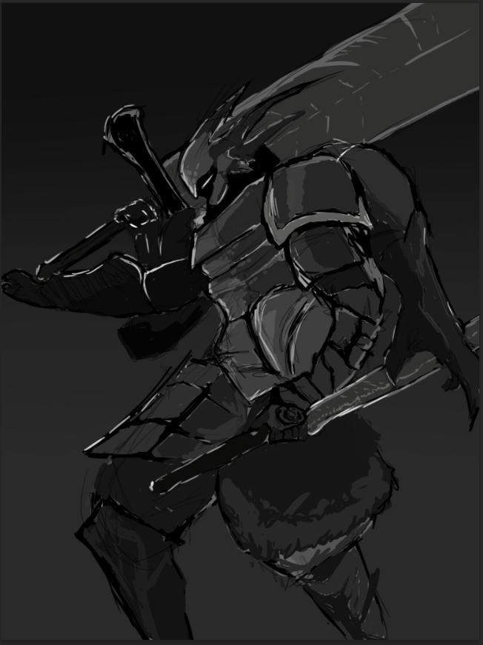

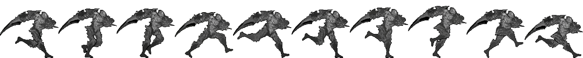

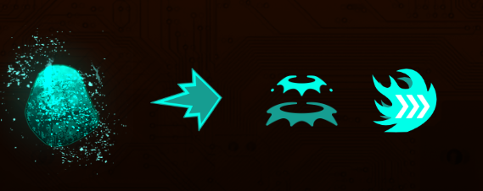

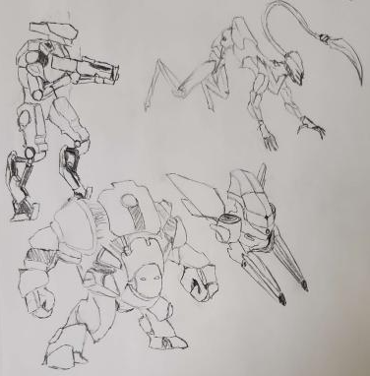

Top left - walkers

Top right – fast killer.

Bottom left – tank

Bottom right – like a flying walker

Game Art In-Game

Background Art

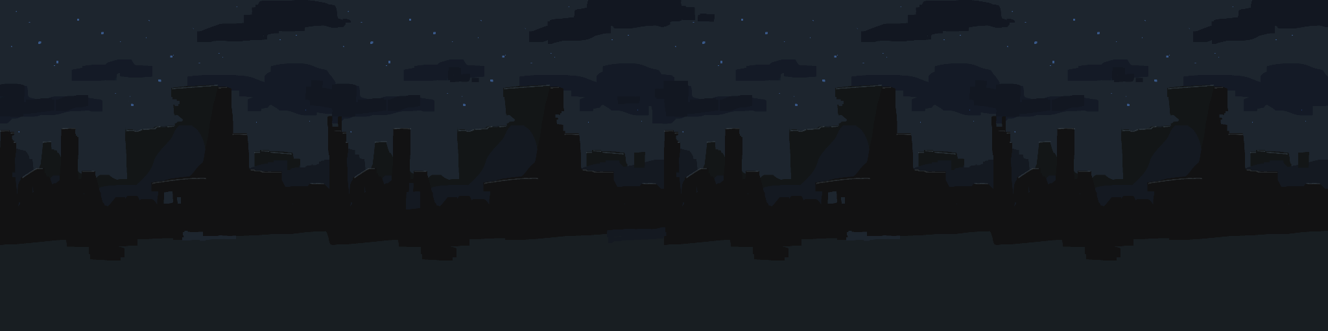

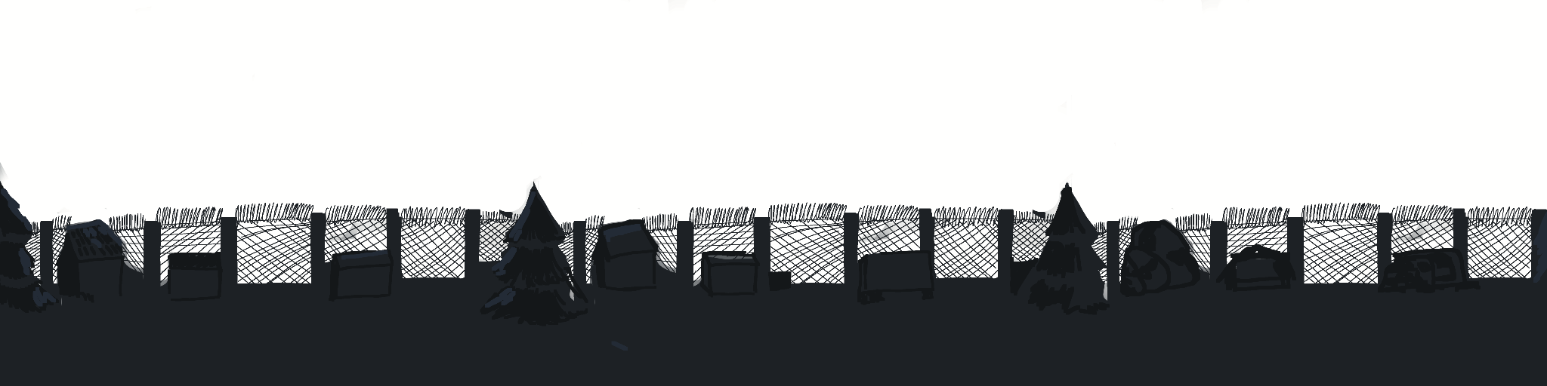

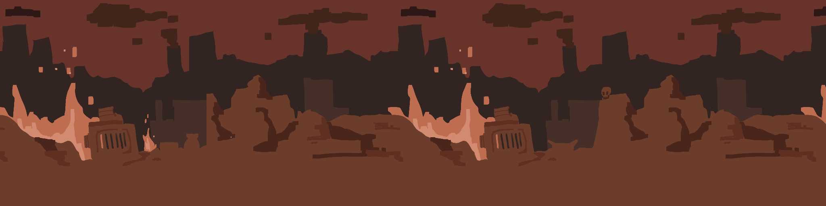

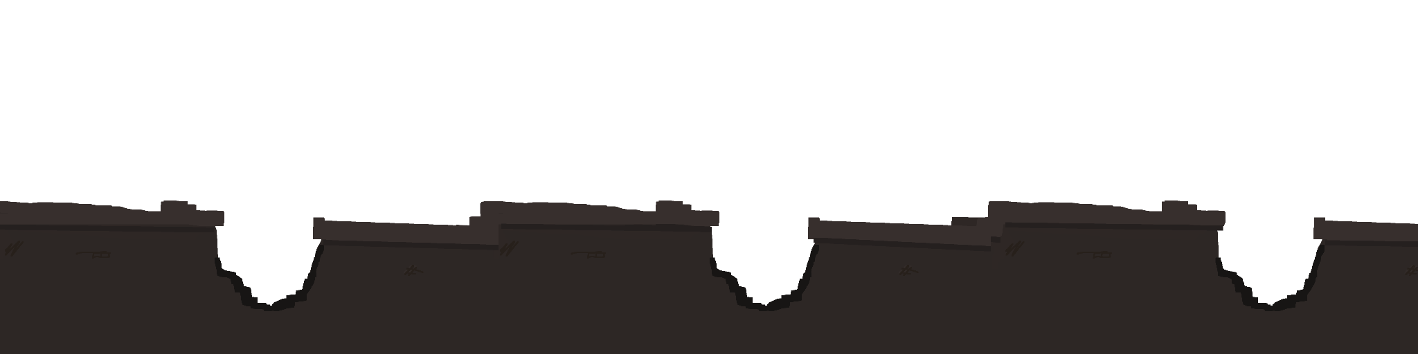

**In Game Sprite**

Player

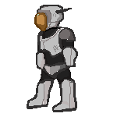

Enemy

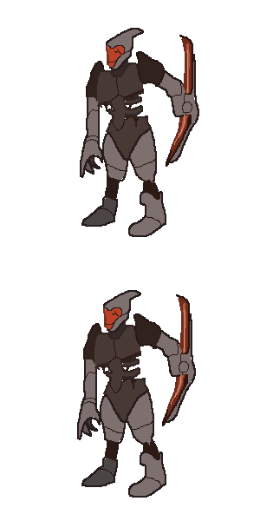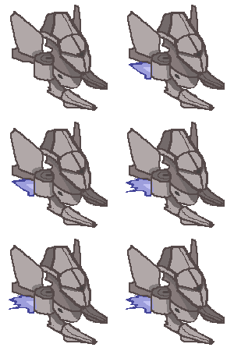

# 

# 

Items & Icons

# 

# Live Service Plan

Day One Launch

* Day One Critical Bug Fixes

During week 1

* Continuation of bug fixes
* Updates and quality of life changes

After a month and beyond

* DLC: Beyond the Factory
  + A new campaign that is outside of the factory features a new playable character
* DLC: New area/level
  + New types of enemies
  + New abilities to unlock.
  + One more New Optional Area for the player to explore.
* Microtransactions
  + Cosmetics(New cosmetics for the player and enemies)
  + Game OST available for purchase
  + Digital Art Book available for purchase